All sample graphics included in this document are from the work of other users of the designcrowd.com platform; therefore, please do not copy them in their entirety, but use them as inspiration.
Screen 01 - Home
- Please improve this element:
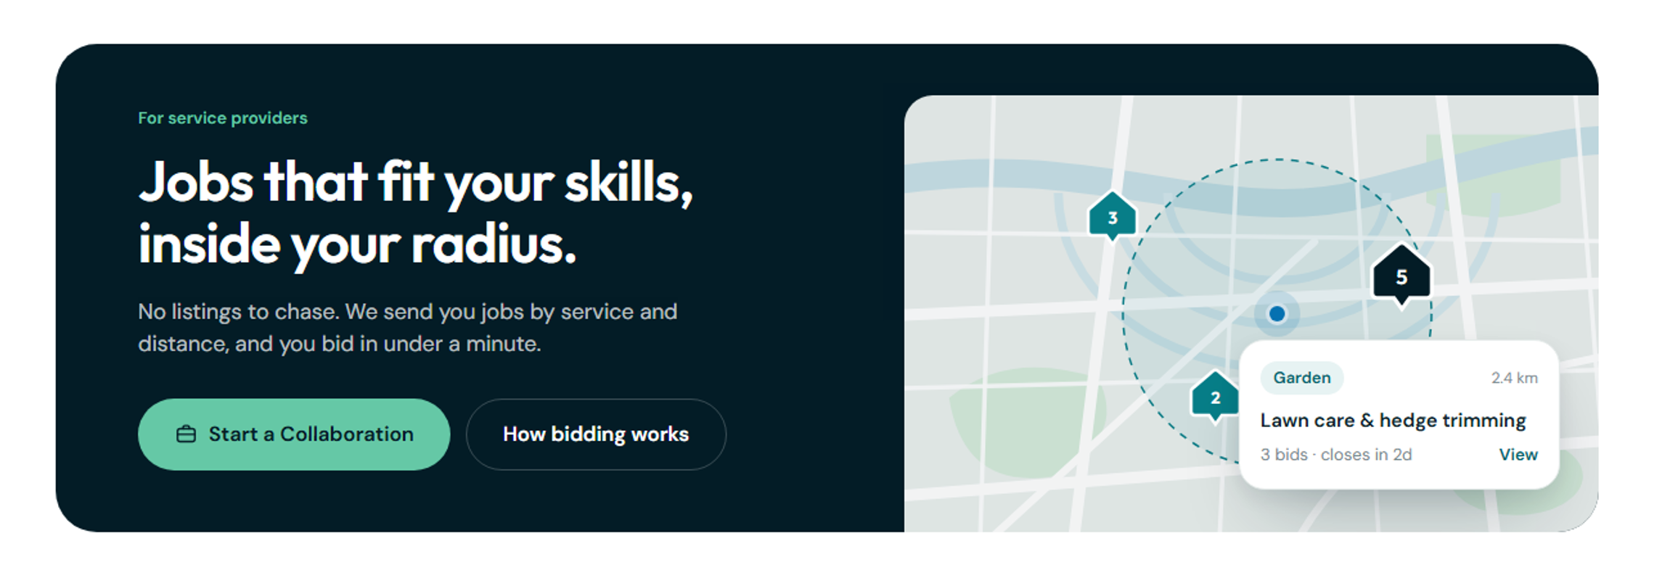
A perfect example of a correction:

- Please remove the items highlighted in red:
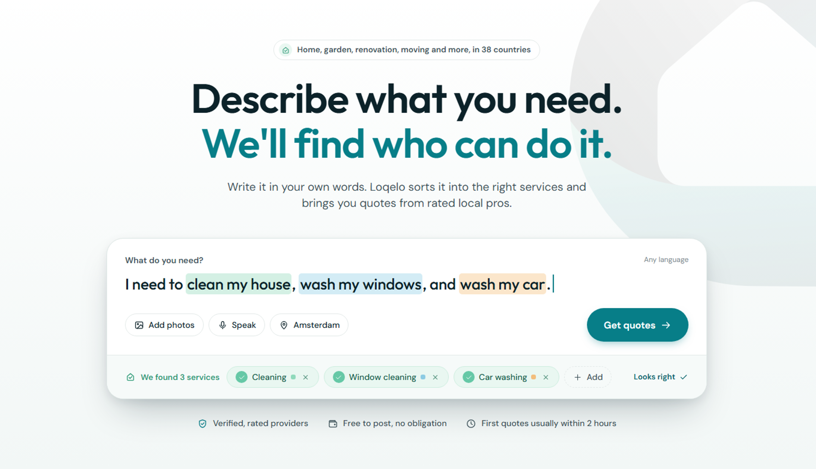

- Please add an image at the top of the page showing a sample of the work. The examples below aren't ideal:
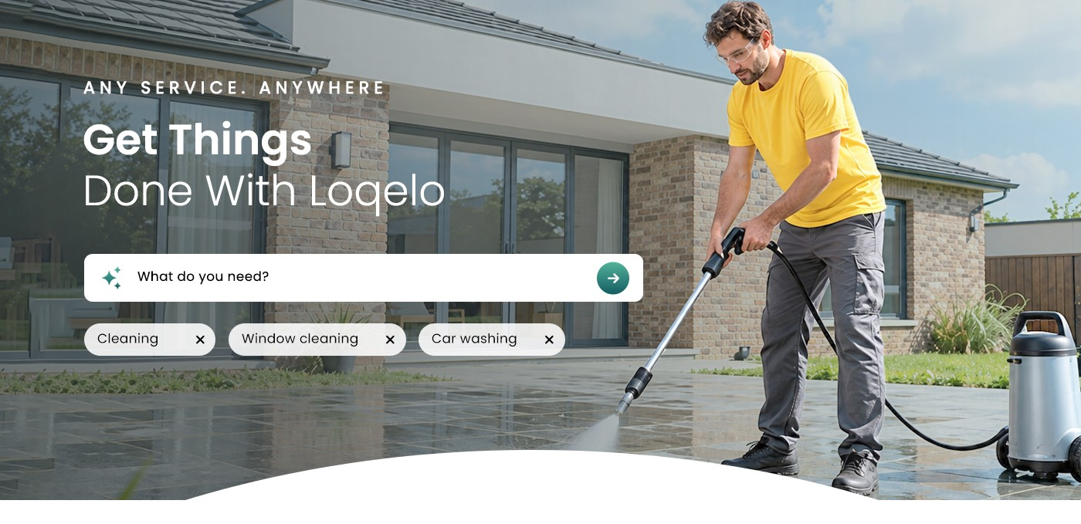


- Please provide a more visual explanation of “How Loqelo works.” Example:
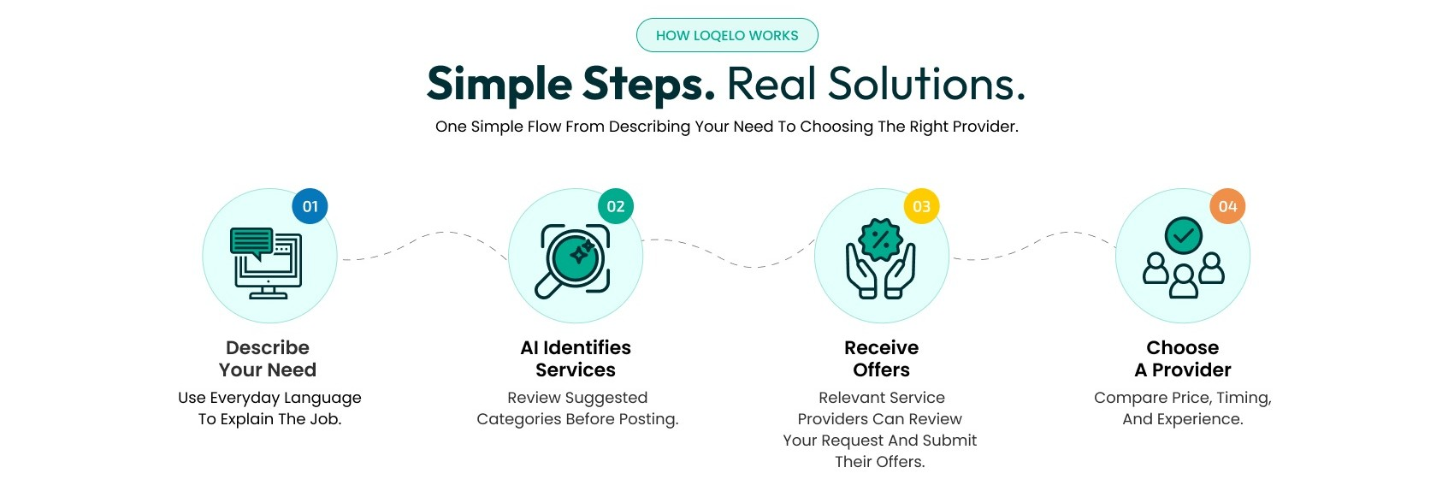

- Please make our logo stand out more and add a new slogan; the current one is a bit too long and not very visual. A perfect example:
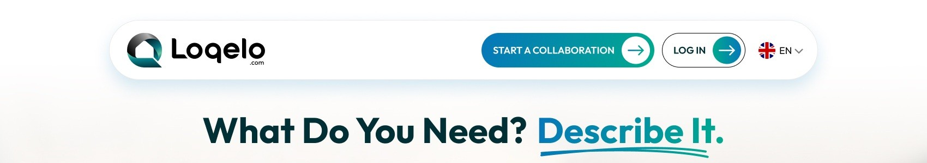

- Please change the names of the main categories to shorter ones:
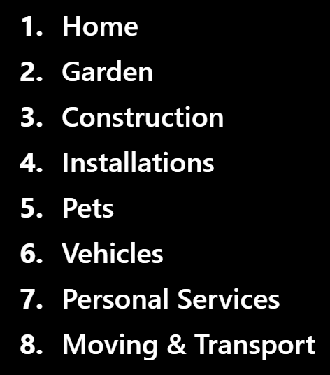
- Please change the display of the main categories to “icon + name + image,” and also choose more appropriate icons for these categories. This example isn't perfect, but it illustrates the intended look:
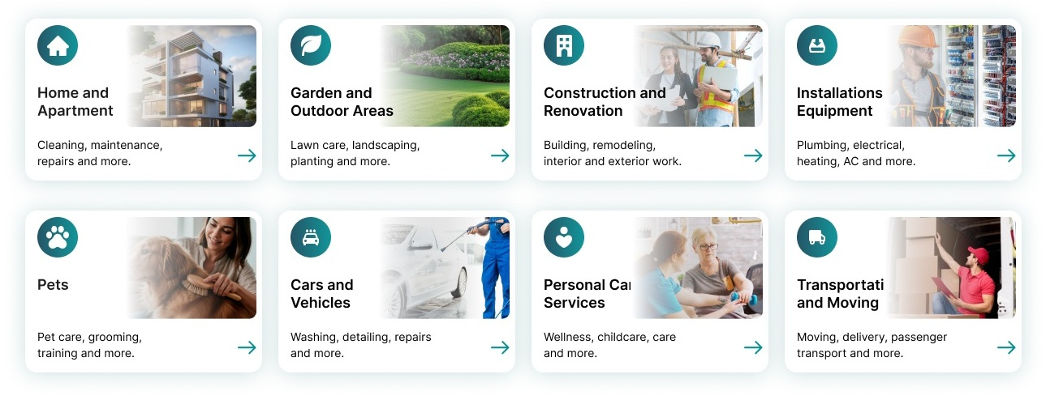
- The main categories could expand into a list of subcategories; I think that would make it easier to read.
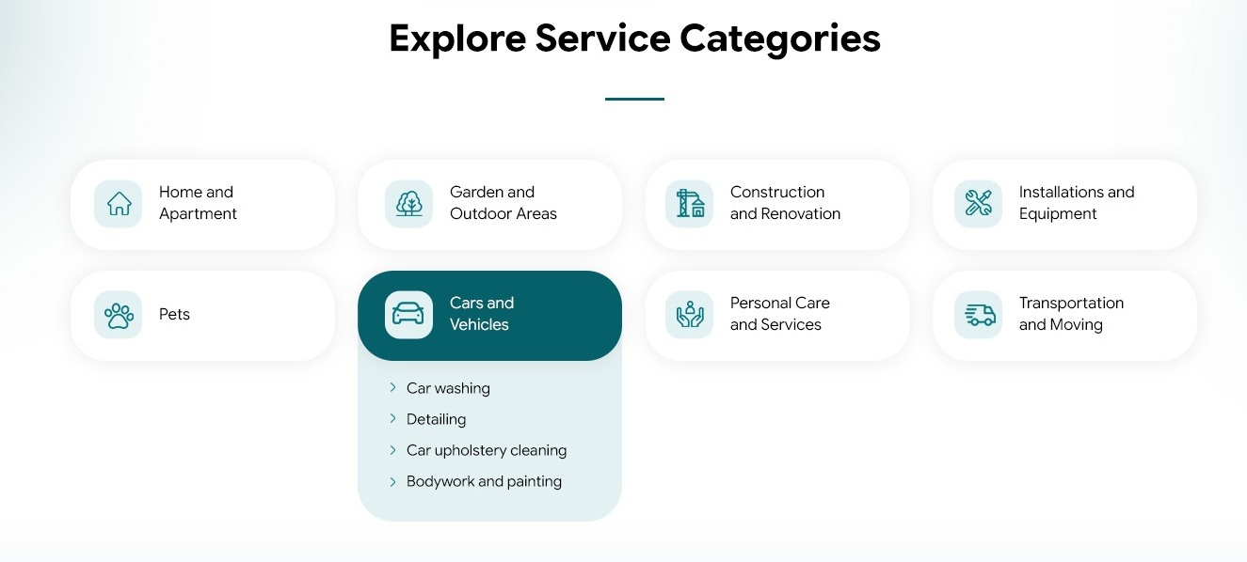
- f the subcategories were selected correctly, they could display icons corresponding to their main categories instead of green markers.
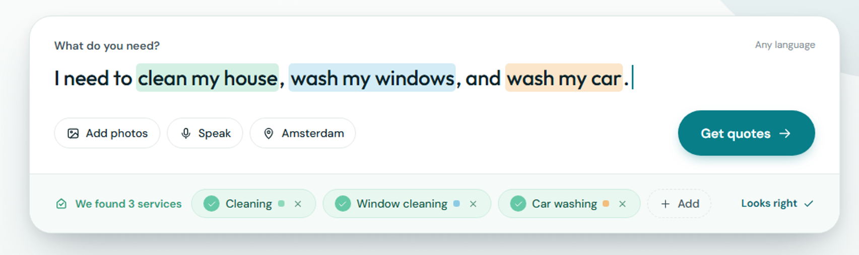

Screen 02 – Post a job
This screen is perfect.

Screen 02b – Job posted
- Please remove the element highlighted in red; for this message, a brief note stating that the ad has been added is sufficient:
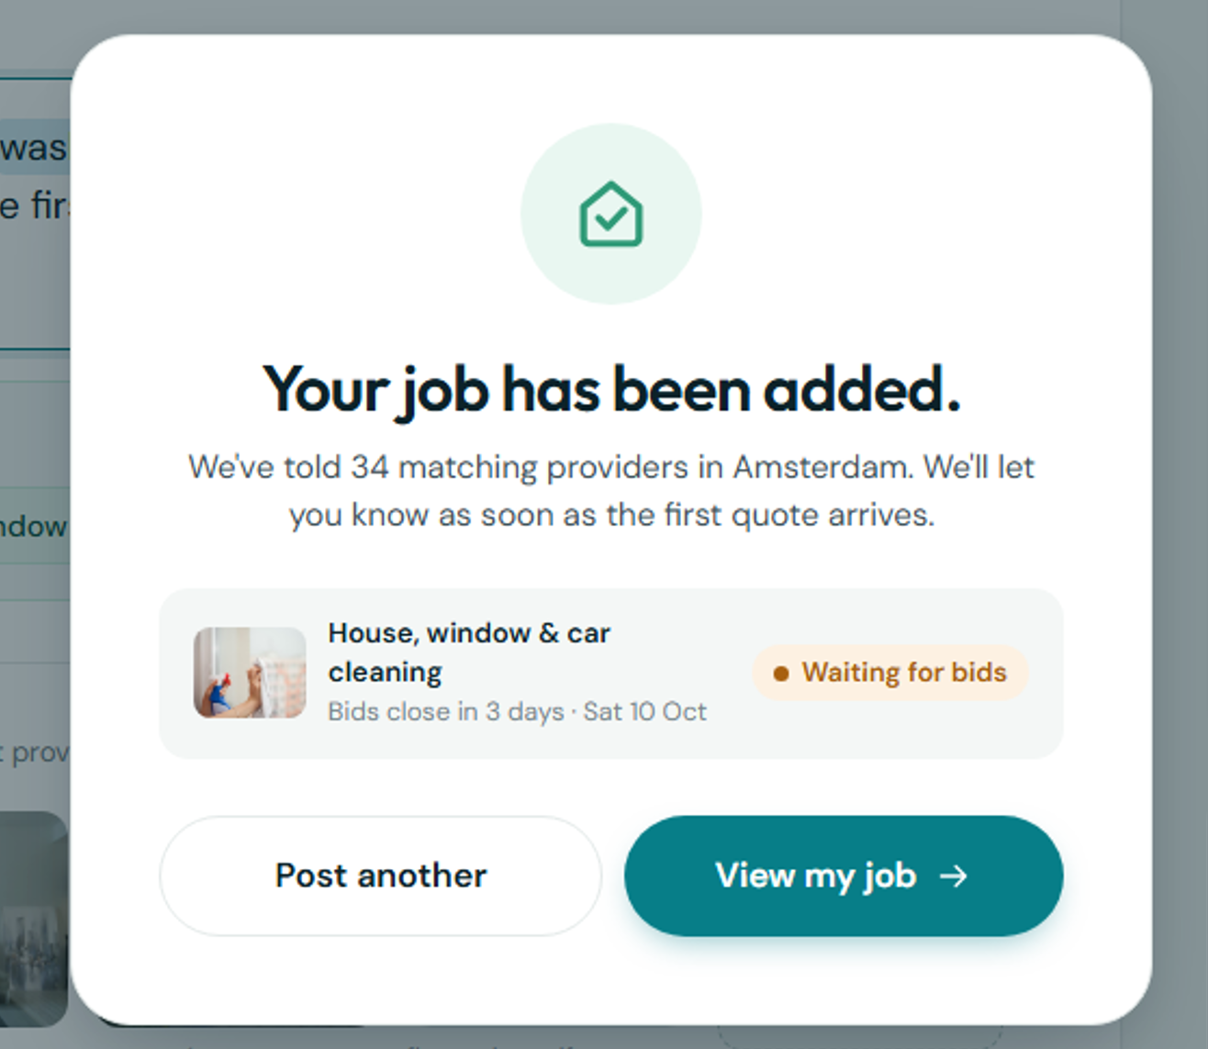

Screen 03 – Client panel
- Please replace all elements highlighted in red with the phrase “Details ->”
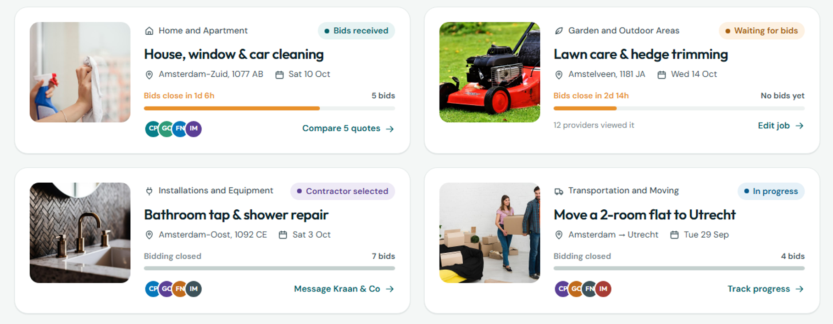
- Please change the color of the timer bar to green or blue:
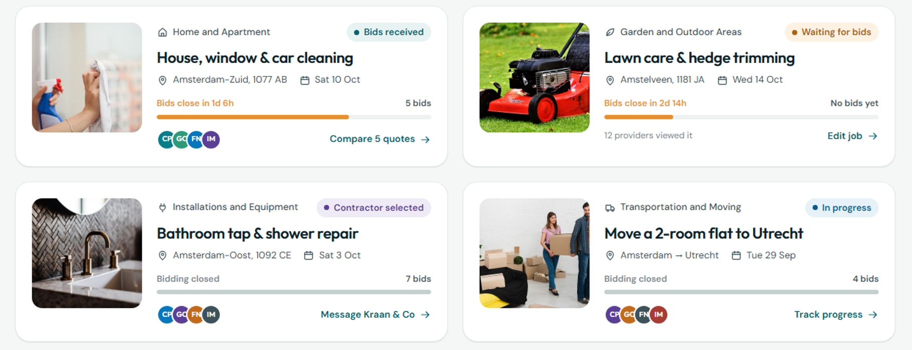
- You can add a “Last activity” box on the right or below, as shown in the example below; it would be good if this box stood out from the others:
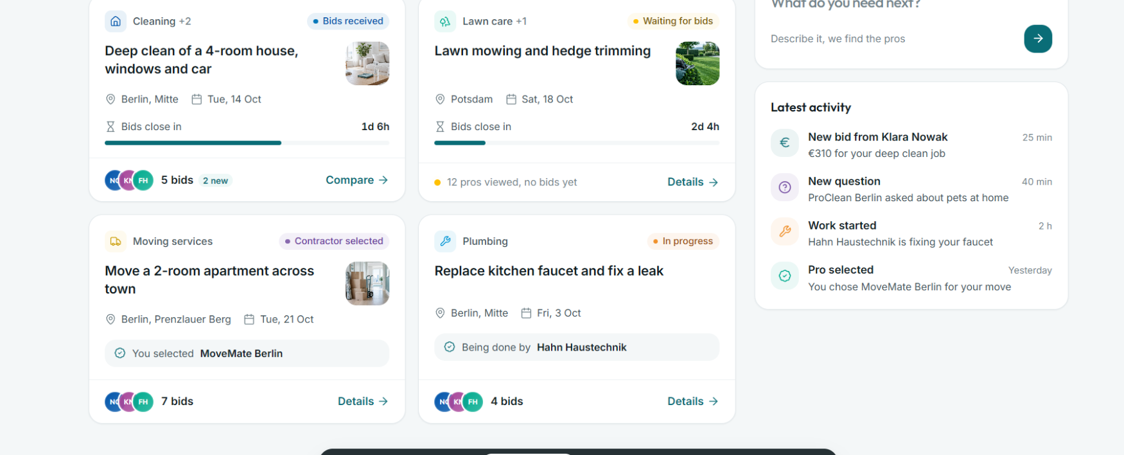

Screen 04 – Job details
- I would like the offers, along with the sorting bar, to be clearly separated from the Q&A section. Please remove the elements highlighted in red.
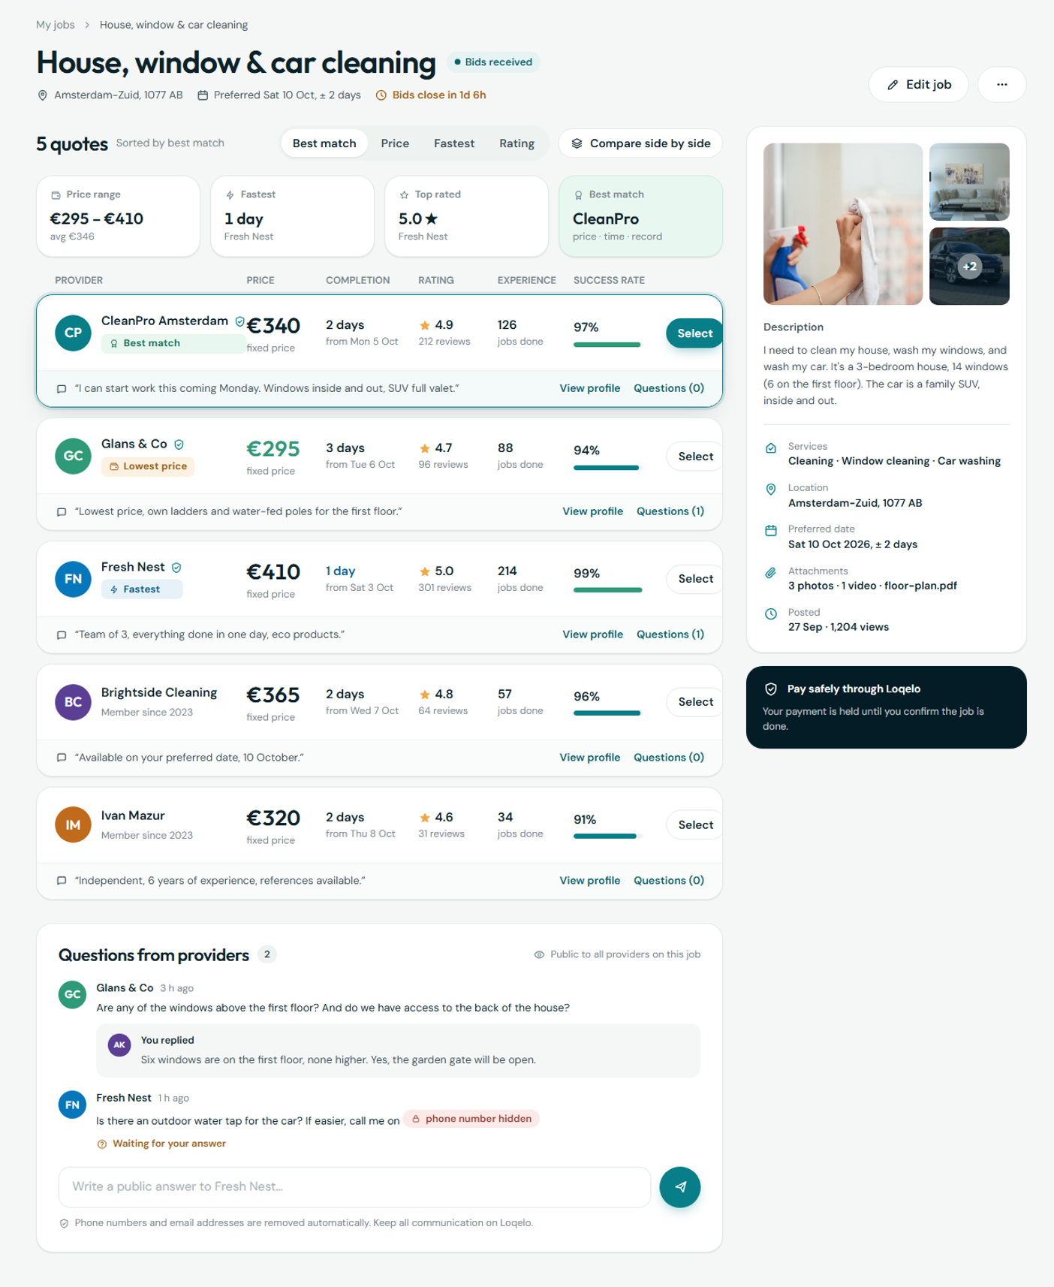

- Please add a chart to the quotes you received showing the price range and the average price: 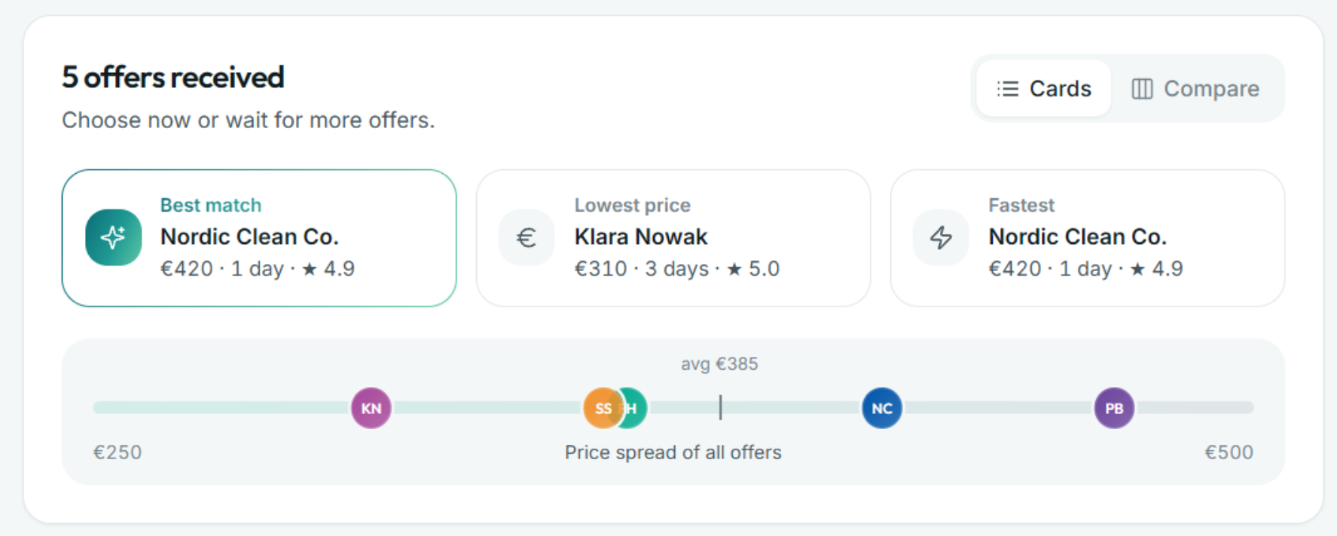

- Please list the customer's responses as follows:
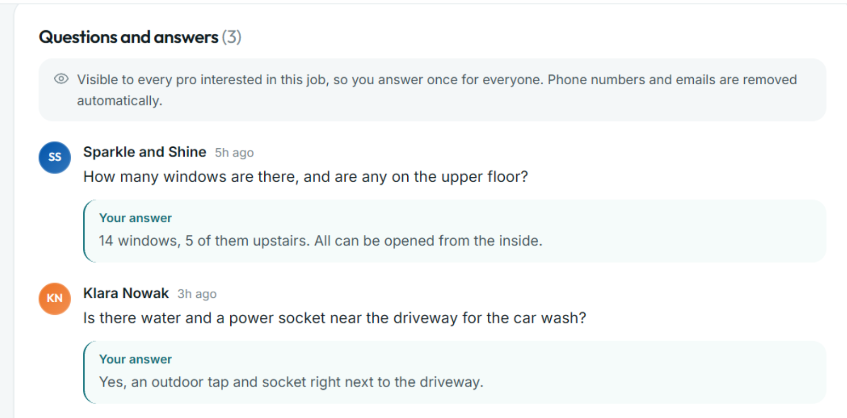

- Please combine “experience” and “success rate” into a single item; this will improve the readability of submitted bids. Please also modify the “Select” button to make it more clearly visible.

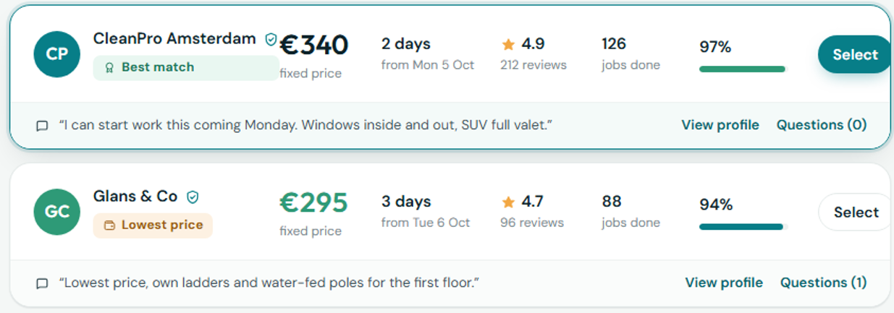
Screen 05 – Contractor panel
- What do you think about changing the icons marked in red on the listings map to small “Loqelo” logos?
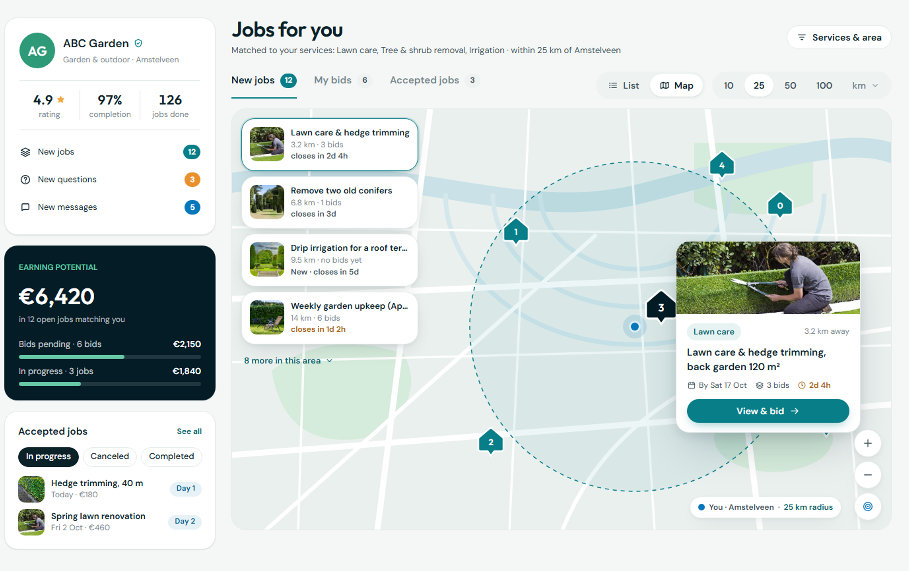

Screen 06 – Bid
- Please separate the map/location of the order from the photos, videos, and other files. The example below isn't perfect, but I hope it helps a little:

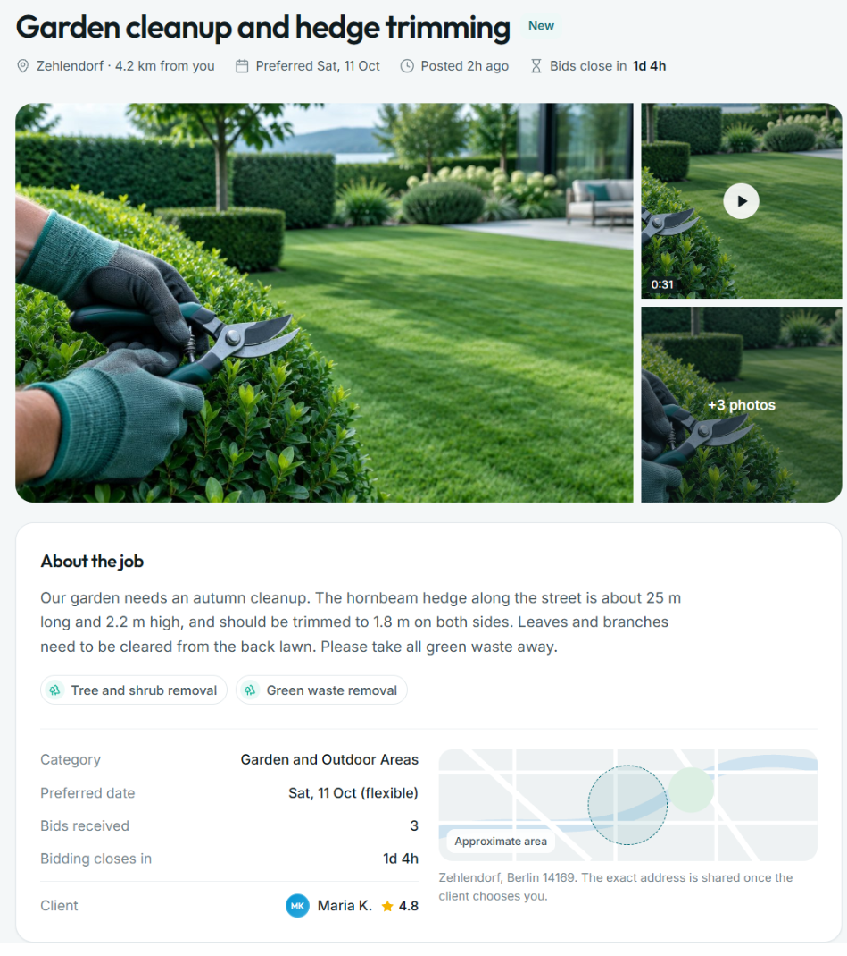

- I also like the more detailed description of the proposal, as in the example below:
